***NAMRC (Nuclear Advanced Manufacturing Research Centre) Cell Management Report***

On starting our production of a low-fidelity prototype, we looked at how we can gather ideas and an understanding of the project. Even though user stories are normally provided by the company, we had to create these ourselves to guide us through the low-fidelity development process.

***User Stories***

***Use Case***

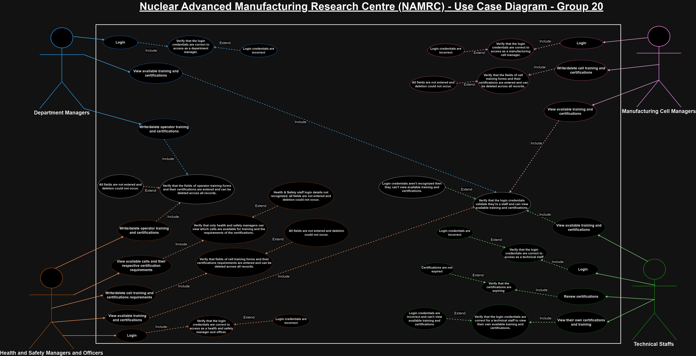

***Entity Relationship Diagram***

***Wireframing***

***Website Formatting including Accessibility Features***  
With the accessibility features, we discussed alt-text for images and making sure the colour combination ensures the foreground and background have a suitable contrast.

Below is a list of features we can incorporate:

* Alternate text for images (in case the user's device does not support images)
* A navigation bar will be available on all pages so users can easily navigate through the system.
* The links that will be used in the navbar to take the user through the pages will also be easy to understand as hovering over each word (e.g. Technical staff login will be a button that will change slightly to show the user they can click on it.
* The colours that are from the website will be used as this keeps in line with the company, we need to make sure the colours on the website are not too bright and have a suitable contrast to allow for easy readability for most of the users.
* Muli font will be used as this is the one that is used on the website
* There will be different font sizes that will be used as some of the text will be larger than others but to stay in line with the existing website design, size 14px can be the main font size.
* The logo will also be shown in the system so that there is no confusion for the user about if they are on the right system or not.
* The system’s visuals will also change depending on the size of the user's screen.

Website Hex values

These colours are the ones that appear on the Nuclear AMRC website, and these colours will be used on the user interface of the system when production of it begins.

* Blue #3555ff
* Purple #904c9c
* Grey #676767